**TUGAS PENDAHULUAN**

**PEMROGRAMAN PERANGKAT BERGERAK**

**MODUL VI**

**INTERAKSI PENGGUNA**



**Disusun Oleh :**

**Rafli Dhafin Kamil – 2211104018**

**S1SE0601**

**Asisten Praktikum : Muhammad Faza Zulian Gesit Al Barru**

**Aisyah Hasna Aulia**

**Dosen Pengampu :**

**Yudha Islami Sulistya, S.Kom., M.Cs.**

**PROGRAM STUDI S1 SOFTWARE ENGINEERING FAKULTAS INFORMATIKA**

**TELKOM UNIVERSITY PURWOKERTO 2024**

**TUGAS PENDAHULUAN**

**A. SOAL NOMOR 1**

1. Pada tugas pendahuluan ini, buat project Flutter baru
2. Implementasi Bottom Navigation Bar:
   * Tambahkan BottomNavigationBar pada halaman aplikasi.
   * BottomNavigationBar memiliki 3 item menu dengan label: "Home", "Wisata", dan "Profil".
   * Setiap kali memilih salah satu menu di BottomNavigationBar, halaman yang ditampilkan berubah sesuai menu yang dipilih.
   * Home: Menampilkan teks "Ini adalah halaman Home".
   * Wisata: Menampilkan teks "Ini adalah halaman Wisata".
   * Profile: Menampilkan teks "Ini adalah halaman Profil".
3. Referensi
   * Website : <https://api.flutter.dev/flutter/material/BottomNavigationBar-class.html>
   * Youtube : <https://www.youtube.com/watch?v=xKeyCJgK_MM>

**Contoh Output**

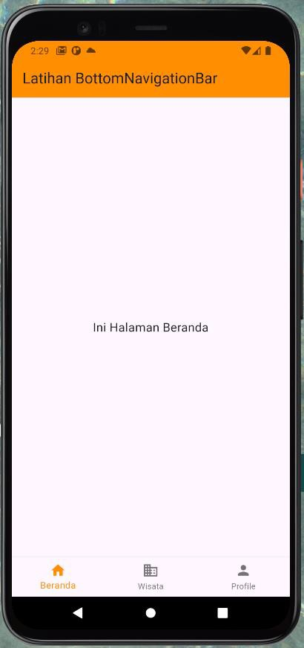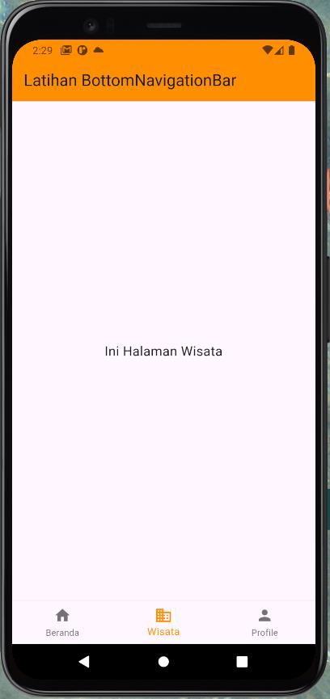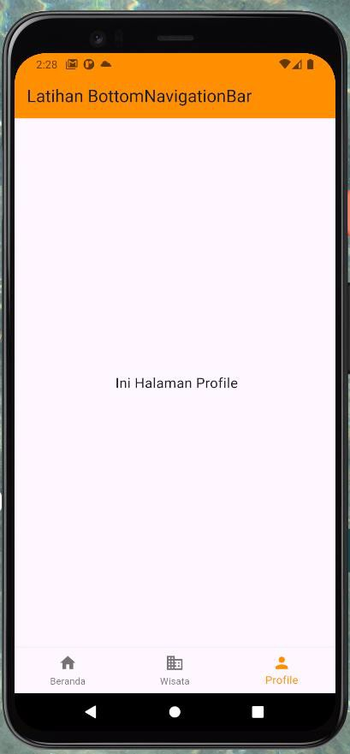

**Source code**

|  |
| --- |
| import 'package:flutter/material.dart';  void main() {    runApp(const MyApp());  }  class MyApp extends StatelessWidget {    const MyApp({super.key});    @override    Widget build(BuildContext context) {      return MaterialApp(        title: 'Flutter Demo',        theme: ThemeData(          colorScheme: ColorScheme.fromSeed(seedColor: Colors.deepPurple),          useMaterial3: true,        ),        home: const MyNewHomePage(title: 'Flutter Demo Home Page'),      );    }  }  class MyNewHomePage extends StatefulWidget {    final String title;    const MyNewHomePage({super.key, required this.title});    @override    State<MyNewHomePage> createState() => _MyNewHomePageState();  }  class _MyNewHomePageState extends State<MyNewHomePage> {    int _selectedIndex = 0;    static const List<Widget> _widgetOptions = <Widget>[      Text('Beranda Page'),      Text('Wisata Page'),      Text('Profile Page'),    ];    void _onItemTapped(int index) {      setState(() {        _selectedIndex = index;      });    }    @override    Widget build(BuildContext context) {      return Scaffold(        appBar: AppBar(          backgroundColor: Theme.of(context).colorScheme.inversePrimary,          title: Text(widget.title),        ),        body: Center(          child: _widgetOptions.elementAt(_selectedIndex),        ),        bottomNavigationBar: BottomNavigationBar(          items: const <BottomNavigationBarItem>[            BottomNavigationBarItem(              icon: Icon(Icons.home),              label: 'Beranda',            ),            BottomNavigationBarItem(              icon: Icon(Icons.place),              label: 'Wisata',            ),            BottomNavigationBarItem(              icon: Icon(Icons.person),              label: 'Profile',            ),          ],          currentIndex: _selectedIndex,          selectedItemColor: Colors.amber[800],          onTap: _onItemTapped,        ),      );    }  } |

**Screenshoot Output**

**Deskripsi Program**

Membuat Menu App bar Bottom untuk melakukan state dengan navigasi ke page / state lainnya